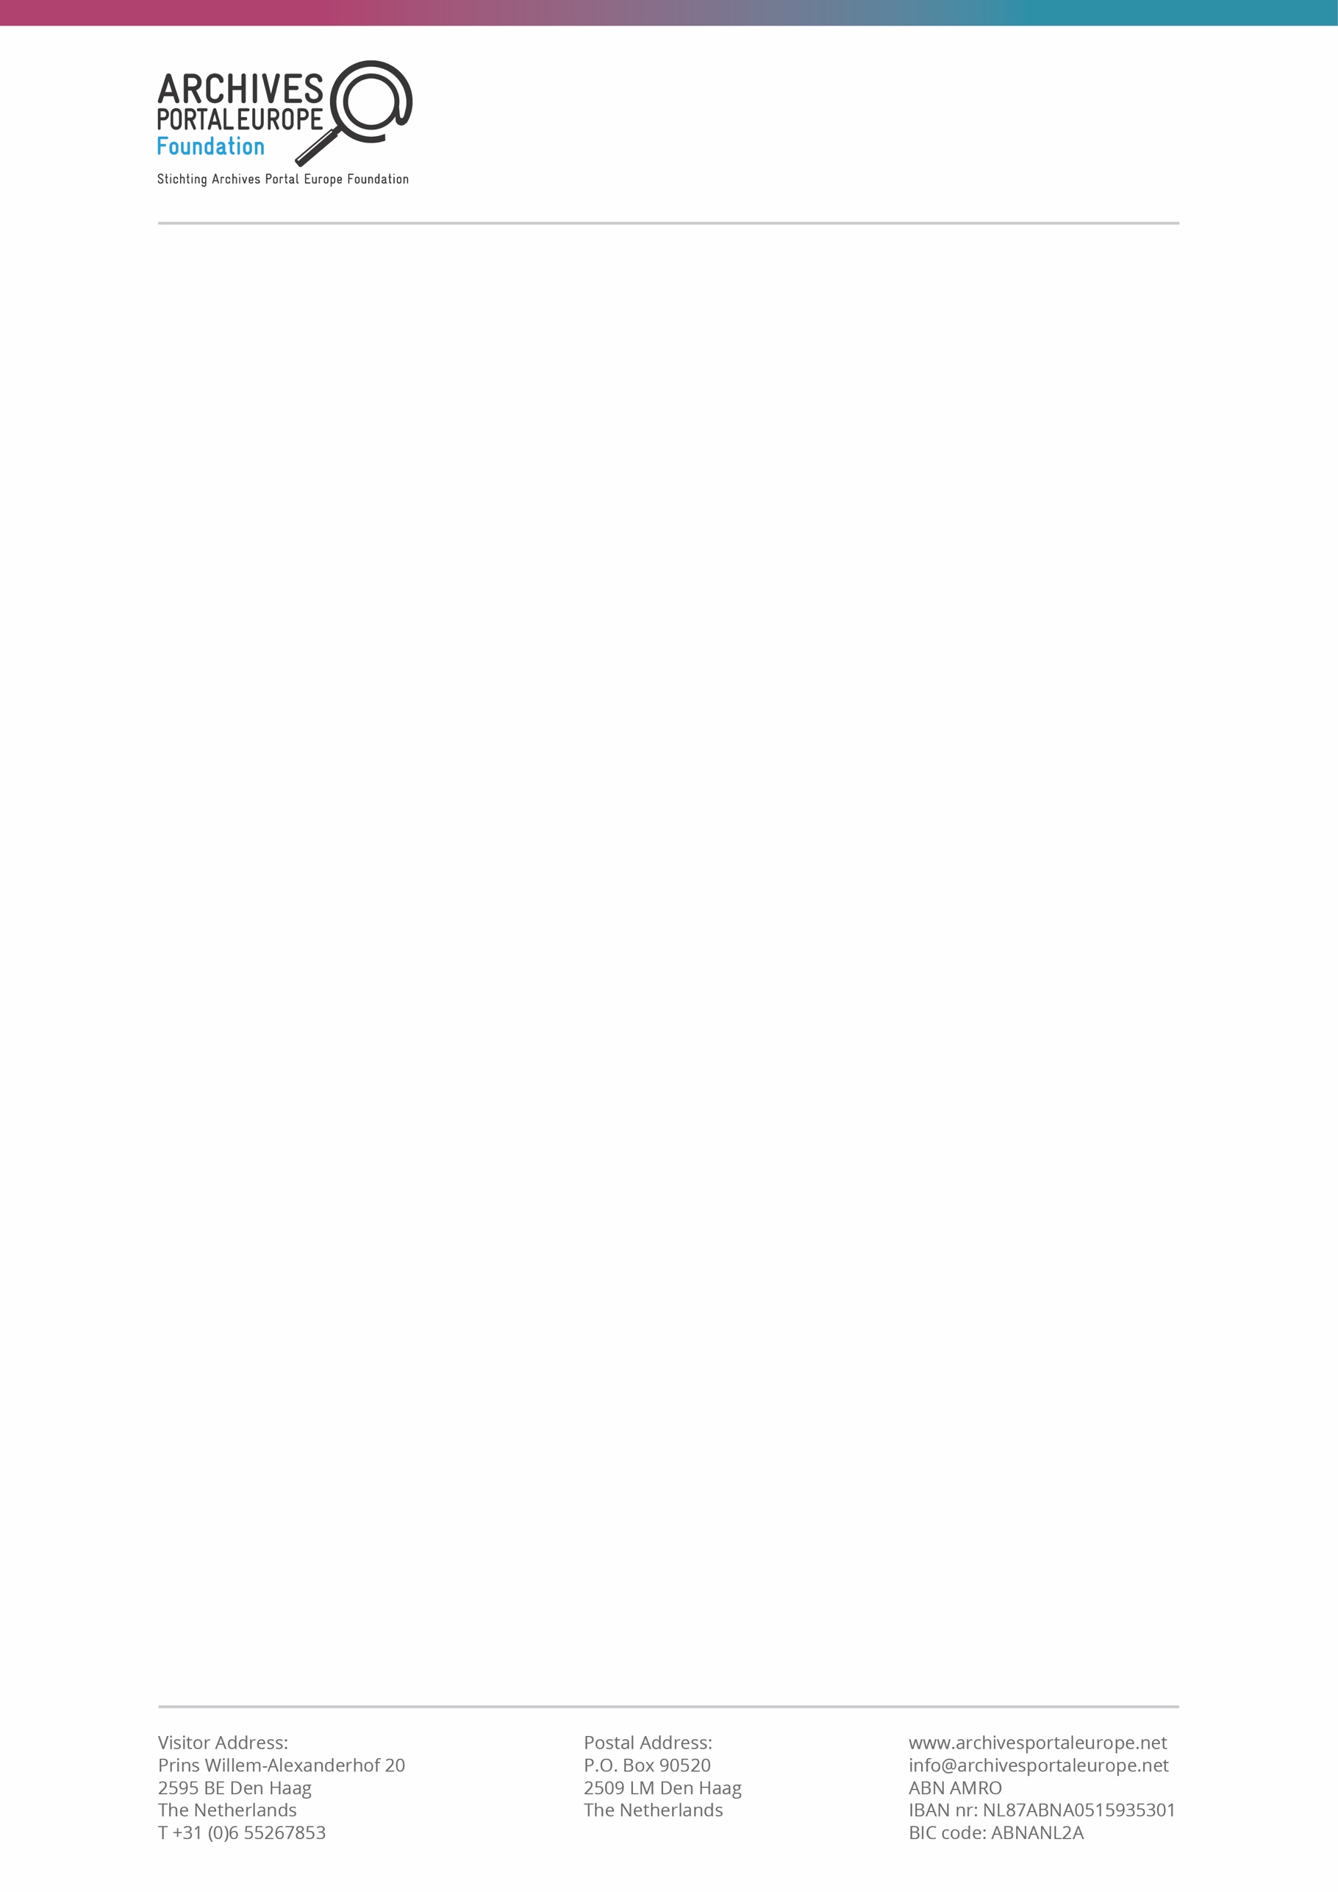

**TERMS & CONDITIONS for participating in the surveys’ price extractions**

For the *Content Providers* and *Aggregators* satisfaction questionnaires, extractions will be made on **1 April** (or the first working day thereafter) for forms received during the **1 October–31 March** period of each annual cycle.

For the *User* satisfaction questionnaire, which is on a rolling basis, extractions will be made on **1 April** (or the first working day thereafter) for forms received during the **1 October–31 March** period, and on **1October** (or the first working day thereafter) for forms received on the **1 April – 30th September** period.

Winning users will be notified shortly after via the email provided in the form. Invalid emails will result in a new extraction.

Only COMPLETE FORMS, including non-mandatory questions, will be considered valid for the draw.

The draws will be made digitally, using [Random.org](https://www.random.org/) – each email will correspond to the number that appears in the Google Form respondents’ list.

The prize for each draw is a 50 EUR voucher from the online bookstore [Ebooks.com](https://www.ebooks.com/en-gb/).

Only one entry per year to the same type of questionnaire from the same respondent will be considered eligible for the draw; winners can still participate in the draw in the following years.

Participants providing more than one valid answer to several types of questionnaires (e.g., both users and content providers form) will be eligible for all related draws.