Π197. Teaching with Archives Portal Europe: the Portal and its usability in History Education

Batzeli Anna
Historian / Postdoc Researcher /
Archives Portal Europe Ambassador

Abstract
Archives Portal Europe (https://www.archivesportaleurope.net/) is an online archive catalogue repository which allows simultaneous archival research in thousands of institutions from more than thirty European countries in twenty four languages (and five different alphabets, including Greek) through one simple online search system. Archives Portal Europe was established in 2009 and currently holds information on around seven thousand archival institutions (national archives, community archives, parish archives, university archives, corporate and private archives), of which over a thousand actively contribute with content, and it holds more than two hundred eighty million archival descriptive units. At the same time, Archives Portal Europe is constantly expanding to make more material available for research. Aim of the current paper is twofold: to present Archives Portal Europe and how it can be utilized by History Educators in Greece or History Educators willing to teach Greek History through two example teaching scenarios.

Key Words: Archives Portal Europe, History Education, Online sources, Teaching Scenarios

1. Brief Introduction of Archives Portal Europe
The Archives Portal Europe (https://www.archivesportaleurope.net/) was established in 2009 with the aim of consolidating descriptive archival catalogues from countries across Europe. Today, Archives Portal Europe provide access to archival items and descriptions from over thirty countries. These catalogues are available in twenty four languages, spanning five different alphabets (such as Latin, Cyrillic and Greek), and originate from diverse institutions including national archives, community archives, parish archives, university archives, corporate, and private archives. Currently, the Archives Portal Europe contains information on approximately seven thousand archival institutions, with over a thousand actively contributing content. It houses more than two hundred eighty million archival descriptive units. Additionally, the Archives Portal Europe is continually expanding its database to provide access to more materials for research purposes.

2. Archives Portal Europe: The Portal and How it works
2.1. Online Search in Archives Portal Europe
Archives Portal Europe serves as an invaluable resource for digital archival research, particularly for history educators, historians, researchers and archivists engaged in aspects and topics related to the European History, History of European countries and/or European countries’ relations with other European and non-European counties. Through a simple keyword search, for example the word “Greece'', researchers can access over 3,360 items related to Greek history and Greece bilateral relations with other countries. These items are held to over thirty archival institutions from more than twenty countries. Indicative examples of the research outcomes include i. ‘Hospital Lists from Greece’ from 1938, from the collections of the International Institute for Social History (Internationaal Instituut voor Sociale Geschiedenis), which is based in the Netherlands (see figure 1); ii. a letter of Greeks from Morea (Peloponnese, Greece) to the King Philip II of Spain requesting for help in their fight against the Ottoman Turks. This letter, sent on July 3, 1582, is part of the collections of the General Archive of Simancas (Archivo General de Simancas) in Spain (see figure 2) and iii. A lithography of the coat of arms and the flag of Greece from the Hessian State Archives Darmstadt, Germany (Hessisches Staatsarchiv Darmstadt). The lithography also illustrates the coats of arms and the flags of Portugal, Denmark, Romania, Switzerland, Bulgaria, Serbia, Luxembourg, Montenegro, Andorra, Marino and Monaco and it was created during 1880 (see figure 3).
These indicative examples highlight the wide range of the topics, as well as, the wide spatial and temporal range of the available items in Archives Portal Europe, which can enable researchers to fill research lacunas in their field, covering various perspectives without needing to consult individual archives separately. Apart from simple keyword search, researchers can apply advanced search by keyword, topic, institution or document type in multiple languages and access archival descriptions of relevant digitized documents and digital objects (such as photographs) whenever available.

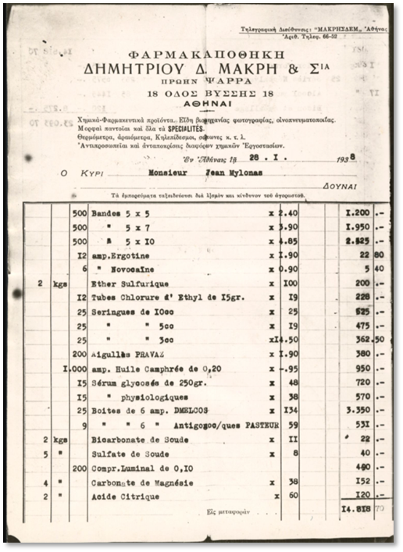
Figure 1: ‘Hospital Lists from Greece’ from the collections of the International Institute for Social History (Internationaal Instituut voor Sociale Geschiedenis), the Netherlands (source: archivesportaleurope.net).

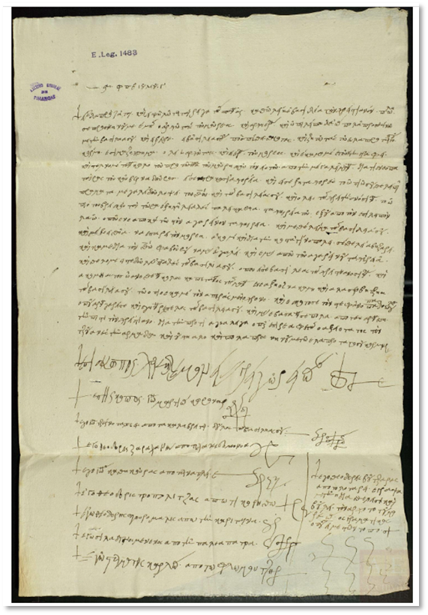
Figure 2: letter of Greeks from Morea (Peloponnese, Greece) to the King Philip II of Spain requesting for help in their fight against the Ottoman Turks. This letter, sent on July 3, 1582, is part of the collections of the General Archive of Simancas (Archivo Gen General de Simancas) in Spain (source: archivesportaleurope.net).
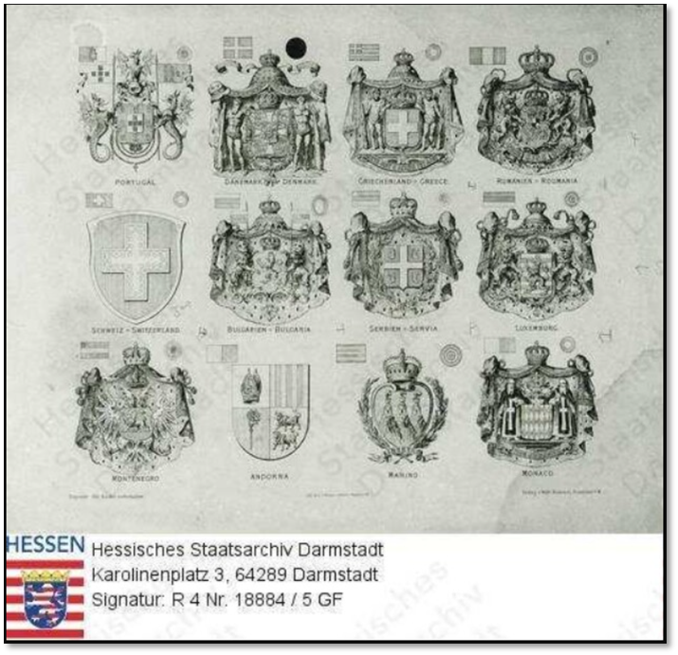

Figure 3: Lithography of the coats of arms and the flags of Greece, Portugal, Denmark, Romania, Switzerland, , Bulgaria, Serbia, Luxembourg, Montenegro, Andorra, Marino and Monaco, 1880, the Hessian State Archives Darmstadt, Germany (Hessisches Staatsarchiv Darmstadt), source: archivesportaleurope.net.

As stated above, researchers may also apply research in Greek language. The outcomes include, apart from collections held at Greek archival institutions represented in Archives Portal Europe (which are the following: the General State Archives (Γενικά Αρχεία του Κράτους (ΓΑΚ) – Κεντρική Υπηρεσία), Historical Archive of Crete (Γενικά Αρχεία του Κράτους – Ιστορικό Αρχείο Κρήτης) and State Archives of Cephalonia (Γενικά Αρχεία του Κράτους – Αρχεία Νομού Κεφαλληνίας), archival items in Greek language held at non-Greek archival institutions, such as the Historical Archives Of The European Union (see for ex. the following item ‘ΚΑΝΟΝΙΣΜΟΣ (ΕΟΚ) άριθ./81 ΤΟΥ ΣΥΜΒΟΥΛΙΟΥ περί τροποποιήσεως τού κανονισμού (ΕΟΚ) άριθ. 4/81 όσον άφορά τήν τιμή παρεμβάσεως πού έφαρμόζεται στήν Ελλάδα στόν τομέα τού έλαιολάδου γιά τήν περίοδο έμπορίας 1980/1981 (ELL) / PROPOSAL FOR A COUNCIL REGULATION (EEC) amending Regulation (EEC) N° 4/81 in respect of the intervention price applicable in Greece in the olive oil sector for the 1980/81 marketing year (presented by the Commission to the Council) (ENG)’ at archivesportaleurope.net)).

2.2. A Search Engine for European Archives
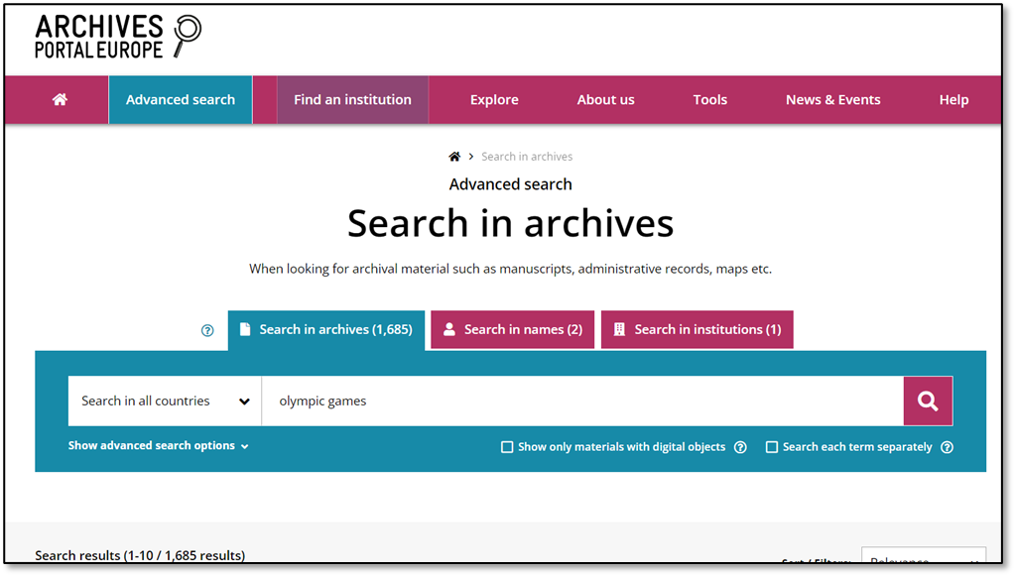
The Archives Portal Europe has recently exceeded 300 million finding aids. This vast repository of available sources greatly aids historians and history educators in archival research. However, it's recommended to employ advanced search techniques, as single-word searches may yield broad results. For instance, a simple search for 'Olympic Games' can yield over 1,680 items (see figure 4, below).
Figure 5: Application of Search Filters to narrow down the search results.
Figure 4:Search results of the term “Olympic Games”.
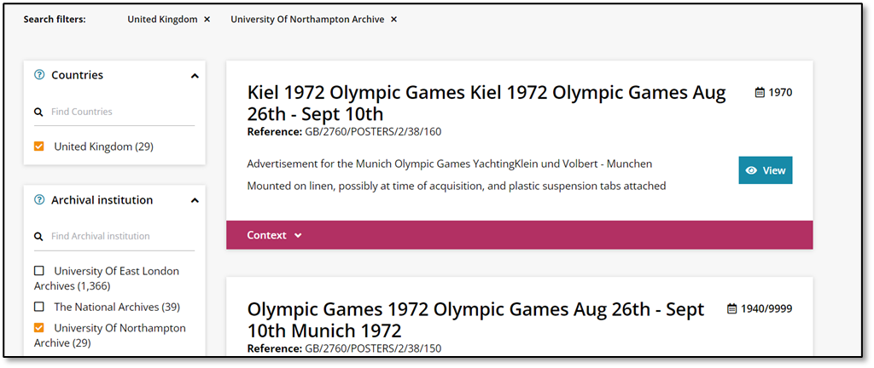

To refine search results, users can apply additional filters such as "Country" and "Archival Institution" to focus on specific countries or institutions of interest (see figure 5 above, where the search results have been narrowed down to just 29 items).
A beginner in Archives Portal Europe may try multiple searches to get familiarised with the Portal and to detect all archival items related to his research subject. It should be added that Archives Portal Europe provide access only to the link to digitised collections (held on the webspace of their institutions) and/or descriptions of the collections. If digital items or detailed descriptions are not available, one has to contact the respective institution, prior to organising a field visit.
Additionally, Archives Portal Europe provide some tips and guides for search in the Portal at the following link: archivesportaleurope.net
Researchers can further facilitate the usage of the Portal through contributing in the development of search with a theme-based function. Theme-based topics are the results of a collective effort between archivists and researchers. The Archives Portal Europe Content Providers assign a topic to their archival collections as they ingest them in Archives Portal Europe, and users and volunteers can improve this by also assigning topics to the documents they search and creating new topics (for more information, see archivesportaleurope.net). Archives Portal Europe also runs special laboratories and workshops to create new topics. To know more about how topics are organised and created, please visit Portal’s research tools section at: archivesportaleurope.net

2.3 Innovation and Constraints of the Archives Portal Europe
The Archives Portal Europe introduces a novel approach to archival research: rather than selecting a single archive to visit and perusing its findings on-site, it allows users to begin with their desired subject and explore thousands of archival catalogs spread across Europe using keyword searches.
The extensive scope of the Archives Portal Europe project, which involves digitizing centuries' worth of archival catalogs from hundreds of thousands of institutions, means that it is an ongoing endeavor. Additionally, the availability of its repository relies on the resources and capabilities of each participating institution to continue their digitization efforts. Consequently, it is essential to bear several considerations in mind when utilizing the portal.
Firstly, the search engine interprets a word as a sequence of characters to match within the repository, rather than considering its semantic meaning. Furthermore, the portal's high multilingualism requires careful consideration; for instance, searching for "Greece" may not include results for "Grèce" (French), "Grecia" (Spanish), "Griechenland" (German), "Ελλάδα" (Greek), "Гърция" (Bulgarian) and so forth. While wildcards and boolean operators, as detailed in the Research Tools section, can mitigate some spelling issues, these measures currently require manual application and are not automated.
Moreover, all information within the portal, including archival descriptions and additional metadata like "Topic," is managed individually by each institution, resulting in varying levels of accuracy. For instance, some collections lack descriptions entirely, containing only codes, rendering them effectively unsearchable via keyword queries in their current state. Another common issue pertains to metadata inconsistencies, affecting the functionality of filters. For example, date filters only operate when collection dates are provided in machine-readable format, which is not always the case. Collections titled "Photographs, 1900-1920" may include dates within the title but not in the date span metadata, potentially leading to their exclusion when filtering by date.
Similarly, the "Topic" filter, which could offer a valuable alternative to keyword searches, is presently utilized by institutions in only four countries. Archives Portal Europe is developing an automated topic detection tool to aid institutions and researchers in assigning topics to collections (find out more on the detection tool here: archivesportaleurope.net), though this remains a work in progress.

2.4. Ways to get involved with Archives Portal Europe
Historians, History Educators, archivists, and researchers have the opportunity to engage with Archives Portal Europe in various capacities: as Registered Users, Ambassadors, Content Providers, Country Managers, or Associates:
▪ As a Registered User, you'll have access to your personal virtual office on Archives Portal Europe, enabling you to save searches, share them with others, and collaborate within the portal. All features are offered completely free of charge.
▪ Ambassadors play a crucial role in promoting Archives Portal Europe within their countries, languages, and areas of interest. This position offers to the Ambassadors a unique chance to collaborate closely with archival institutions locally and internationally. Benefits include professional networking, skill development, preferential access to Archives Portal Europe grants, and membership in a global community of researchers and cultural heritage professionals.
▪ Content Providers contribute by uploading material from their archival institutions, making their holdings globally discoverable alongside those of hundreds of other institutions. They also join an international network of archivists, facilitating collaboration on projects and staying informed about the digital evolution of archival heritage.
▪ If your country lacks representation on Archives Portal Europe, you can participate as a Country Manager. Archives Portal Europe, while focused on European history, welcomes archives from around the world and strives to expand its network for greater inclusivity. Advantages of this role include showcasing your country's archival heritage globally, sharing expertise, fostering networking, and forming partnerships.
▪ For those interested in actively shaping the future of Archives Portal Europe and ensuring its long-term sustainability, becoming an Associate is recommended. Any entity qualifying as a European Archival Institution or European Archival Research Institution can join. Further details on the qualification process are available on the Archives Portal Europe website: archivesportaleurope.net

3. Teaching with Archives Portal Europe
3.1. Archives Portal Europe usability in History Education
Archives Portal Europe offer several added values that enhance the learning experience and deepen students' understanding of historical topics. First of all, Archives Portal Europe provide students with access to primary source materials such as documents, photographs, maps, and audiovisual recordings that are not readily available in traditional textbooks. This direct engagement with primary sources allows students to analyse historical evidence firsthand and develop critical thinking skills. Moreover, through Archives Portal Europe, History Educators can create authentic learning experiences that simulate the process of historical inquiry and research. Students learn how historians analyse sources, construct narratives, and interpret the past, thereby gaining a deeper appreciation for the complexities of history.
Additionally, Archives Portal Europe enable History Educators to design teaching scenarios with varying levels of complexity, scaffolding support for struggling learners while providing challenges for advanced students. This allows for differentiated instruction and personalized learning experiences. Archives Portal Europe also enable History Educators to design collaborative tasks. These tasks promote teamwork, communication, and peer learning, fostering a sense of community within the classroom. Last but not least, via utilising Archives Portal Europe in History Education, students are offered the opportunity to develop digital literacy skills and familiarize themselves with technology tools commonly used for historical research and analysis. This integration of technology prepares students for the digital demands of the 21st century.

3.2 Example Teaching Scenarios
In this section two example teaching scenarios for History Educators will be presented. The first one aims to get students acquainted with the Industrial Heritage of Greece, while the second example teaching scenarios focuses on the study of World War I. In both scenarios, the tasks are crafted with a foundation in the principles of differentiated instruction and the flipped classroom methodology within a blended learning setting.
History Educators may think additional scenarios, utilizing Archives Portal Europe digital exhibitions, such as the following: The Charta of Greece – 1797 (archivesportaleurope.net), Romani in Europe (archivesportaleurope.net), 100 years of Maria Callas (archivesportaleurope.net), Carnival (archivesportaleurope.net), #AllezDemocracy - Greece: The Law of Epidaurus (archivesportaleurope.net), Acropolis of Athens (Akropolis von Athen) (archivesportaleurope.net), Antisemitic board game produced in 1936 (archivesportaleurope.net), etc.

3.2.1 Example Teaching Scenario no. 1: Industrial Heritage of Greece
The primary objective of Example Teaching Scenario no. 1 is to foster critical thinking among students through reflecting on how technology and innovation affected economy, society and culture. Also, the scenario aims to enrich the knowledge of the students on Greek industrial heritage, as well as, to raise their awareness on the importance of the industrial heritage to cultural identity and memory, its impact on society and the environment and its links to labor history and history of technology. Finally the scenario involves the use of several digital tools, advancing thus digital literacy of the students.
The scenario is addressed to 25-30 students at the age of 16-17, who have good knowledge of English language. Its duration is 4 teaching hours and the preparation time for the History Educator to adjust the teaching materials to his own context is estimated at 2 hour.

Teaching hour | Activities
1st – 2nd | The History Educator will initiate the discussion by presenting the ‘#IndustrialHeritage - Greece: setting Europe in motion’ digital exhibition of Archives Portal Europe (available at: archivesportaleurope.net). Following an introduction on the scenario’s topic and its importance, a classroom discussion will be initiated on the topic and students will be encouraged to share their own views and experiences from visits at Industrial Heritage sites.  Following the end of the discussion, the History Educator will explain to the students how to use and do research in Archives Portal Europe and encourage them to find additional material/archival items related to the scenario’s topic. To this aim, students will be divided into groups of 5. Each group has to present and discuss its search outcomes in the classroom.
3rd – 4th | The students, under the guidance of the History Educator, will be encouraged to identify and create an interactive map of Industrial Heritage sites in their region, utilizing existing digital tools such as Padlet, Google Maps and/or Thinglink. After the end of the activity, the map can be posted on the school website.

The same process could be followed by the History Educator to develop their own scenarios. After the end of the scenario, History Educators are encouraged to obtain students feedback, so as to be able to improve it.

3.2.2 Example Teaching Scenario no. 2: World War I
The aim of the Example Scenario no. 2 is to deepen students knowledge on World War I. During the implementation of the scenario, students will have the opportunity to discuss wars and their impact to communities. As it was the case of the first example scenario, example scenario no. 2 also employees a number of digital tools, preparing thus the students for the digital demands of our era.
Scenario’s target group is students at the age of 16-17, who have good knowledge of English language. Its duration is 5 teaching hours and the preparation time for the History Educator to adjust the teaching materials to his own context is estimated at 2 hour. The scenario can be implemented to a classroom with up to 30 students.

Teaching hour | Activities
1st – 2nd | The History Educator will initiate the discussion by presenting the ‘Panorama pictures from the First World War’ digital exhibition of Archives Portal Europe (available at archivesportaleurope.net). Following an introduction on the scenario’s topic and its importance, a classroom discussion will be initiated on the topic and students will be encouraged to share their knowledge on World War I and their views on war and its impact to the society, economy, policy and culture.  Following the end of the discussion, the History Educator will explain to the students how to use and do research in Archives Portal Europe and encourage them to find additional material/archival items related to the scenario’s topic. To this aim, students will be divided into groups of 3 to 5 persons each. Each group has to present and discuss its search findings in the classroom.
3rd – 4th | The students, divided into groups and under the guidance of the History Educator, will be encouraged to identify photographs, paintings and videos from First World War era utilising both Archives Portal Europe and other online search engines.  Students may focus on a specific topic related to World War I, such as soldiers, women, children, military technology, monuments of World War I, etc.  It is advisable each group to select a topic of their interest and to be encouraged to propose a topic.  After the end of the online research, each group will be asked to create their own exhibition using Canva.
5th | Each group will present their exhibition in the classroom. The exhibitions can be also posted at the school’s website and/or blogspot accompanied by a short introductory article developed by each group with the support of the History Educator.

The same process could be followed by the History Educator to develop their own scenarios. After the end of the scenario, History Educators are encouraged to obtain students feedback, so as to be able to improve it.

4. Closing remarks
Overall, Archives Portal Europe offer added value to History Education by providing access to primary sources, fostering interactive and authentic learning experiences, accommodating diverse learners, promoting collaborative learning, integrating technology, and connecting historical topics to real-world contexts.

